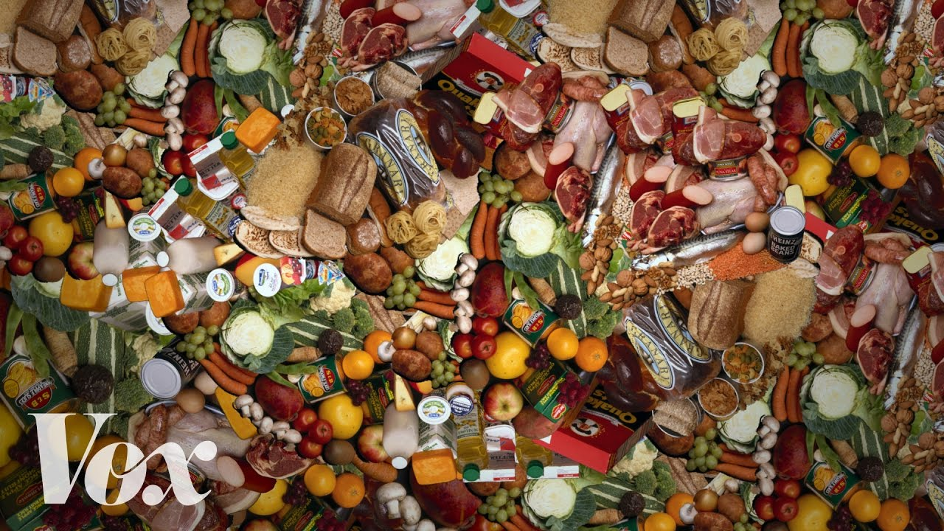**Food waste is the world’s dumbest problem**

*leftovers to feel remorse a tray*

*subliminal subtle surplus edible*

*to take a stand against smth*

*to have smth on your radar*

1) What is the “Food cam”?

2) How much of the produced food in the USA is never eaten?

3) What are the consequences of wasting food?

4) What are the reasons people overbuy and as a result waste much food? Name at least 3.

5) What is “Copia”?

6) How many people did they feed after the Super bowl event?

7) What is your opinion on the problem of food waste? What do you think are the ways to solve the problem?

8) How much food do you waste?

**Food waste is the world’s dumbest problem**

*leftovers to feel remorse a tray*

*subliminal subtle surplus edible*

*to take a stand against smth*

*to have smth on your radar*

1) What is the “Food cam”?

2) How much of the produced food in the USA is never eaten?

3) What are the consequences of wasting food?

4) What are the reasons people overbuy and as a result waste much food? Name at least 3.

5) What is “Copia”?

6) How many people did they feed after the Super bowl event?

7) What is your opinion on the problem of food waste? What do you think are the ways to solve the problem?

8) How much food do you waste?